Revision History

Table of Contents

Use-Case Realization Report
Add Lesson

Issue <1.0>
Revision History
Date | Issue | Description | Author
<dd/mmm/yy> | <x.x> | <details> | <name>

Table of Contents
1. Brief Description 5
2. Flow of Events 5
2.1 Standard Flow 5
2.2 Exceptions 5
3. Interaction Diagrams 6
3.1 Collaboration Diagram for Add Lesson 6
4. Participating Objects 6
5. Class Diagrams 7
5.1 Class Diagram for Add Lesson 7
6. Derived Requirements 7

Use-Case Realization Report
Add Lesson

Brief Description

Flow of Events

Standard Flow

- Portal Admin prepares the XML file, containing all the contents of the lesson, as well as section and page structure, then click “Upload” button to upload this XML file.
- System will check whether the format is valid.
- System will check whether the lesson duplicates with existing lessons.
- System will identify the content of the XML file, and split into “Lesson” and “Section” object, and insert into database accordingly.
- System will display “Successful” message.

Exceptions
- If the XML file format is not valid, the system will display an error message.
- If the lesson to be added conflicts with the existing lessons, system will display an error message.

Interaction Diagrams

Collaboration Diagram for Add Lesson
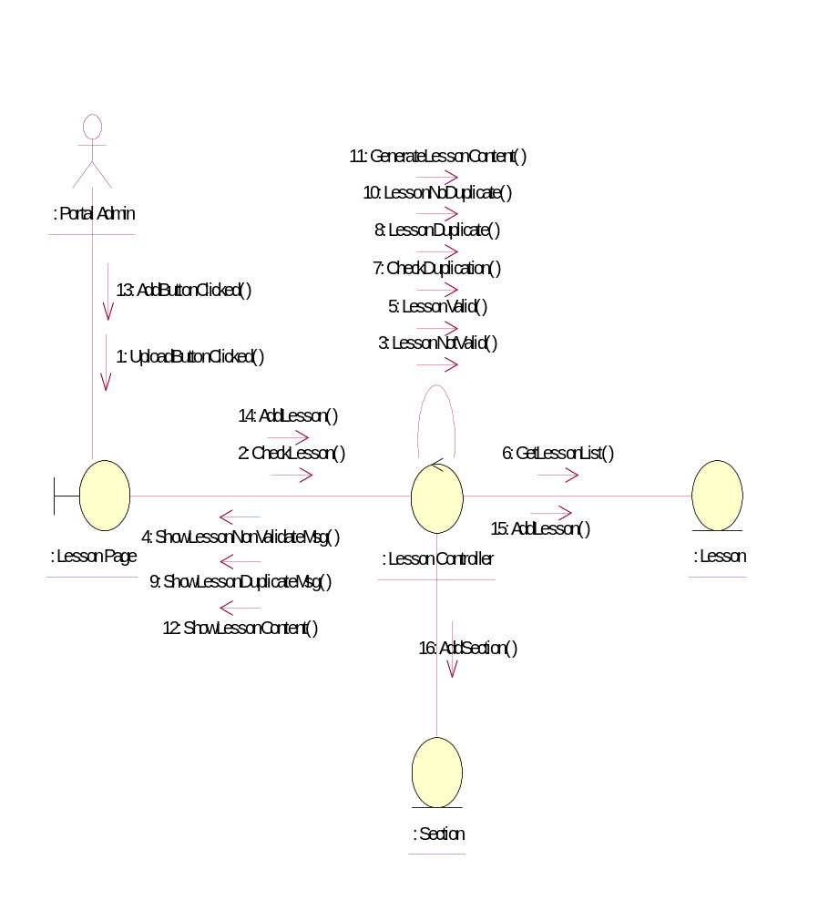

Participating Objects
: Lesson
This entity is the lesson object.
: Lesson Controller
This is the controller to upload, add, delete and modify lessons.
: Lesson Page
This is the page for adding, deleting, modifying lessons.
: Portal Admin
This is the super user of the system.
: Section
This entity is the Section object

Class Diagrams

Class Diagram for Add Lesson
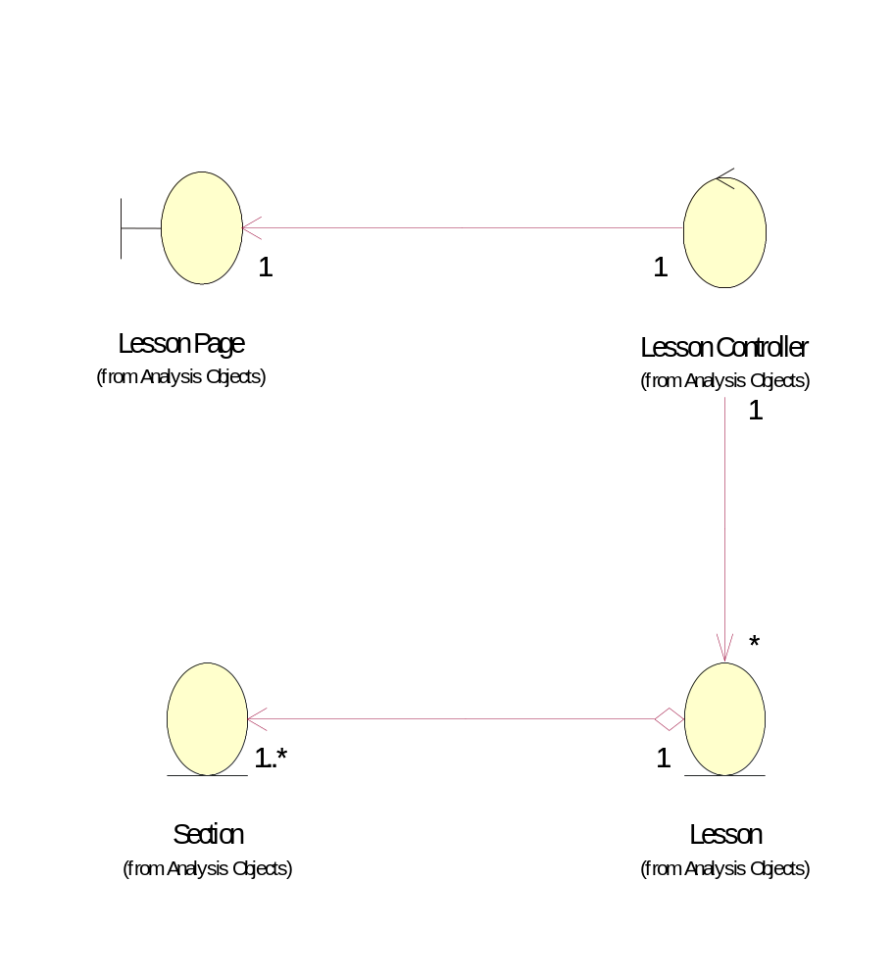

Derived Requirements
Only Portal Admin has access to this page.

